**Batch:B2-2/H2_1 Roll No:-16010122151**

**Experiment 08**

|  |
| --- |
| **Title: To create an effective Story.** |

# Objective:

# *Search/locate and download any Data of Your Choice (Use same dataset if it contains location information)*

# *To learn how to create Story*

# *Include the dashboard/s and worksheet/s into story*

# *Apply best practices to create Story(Colour, font, caption, title).*

# Course Outcome:

# CO1: Learn how to locate and download datasets, extract insights from that data and present their findings in a variety of different formats

# CO3: Apply data visualization best practices

# CO4: Design static charts, interactive Dashboards and data stories

# Theory:

# Describe content related to story:

(Theory related to experiment needed to perform - Students should write)

# 

# Following points should be written by students

# Create Story workspace

# Best practices for telling best stories.

# Integrate the Dashboard and multiple sheets in story.

# Present the story as per the points considered.

# Interpret the each slide of story in detail.

# 

# 

# A World of Subscribers:- The map chart that tells the story of our subscriber base. It's like a colorful map journey that shows the number of subscribers in each state.

# 

# Unveiling Genre :- Through the diverse world of content genres, our Tableau bar chart will showcase the most popular genres, highlighting the top picks of our viewers.

# 

# Movies Take the Spotlight:- As we zoom in, we observe that movie bubbles dominate the chart, both in terms of size and quantity. The movie category is marked by larger and more numerous bubbles, showcasing the prevalence and appeal of films.

# 

# Note: Detail observation needed along screenshots wherever required

**Comparing the Gems:-**In this interactive section, you have the power to compare ratings yourself. Select a few movies and TV shows of interest and view their ratings side by side. It's a tool for finding hidden gems and viewer favorites.

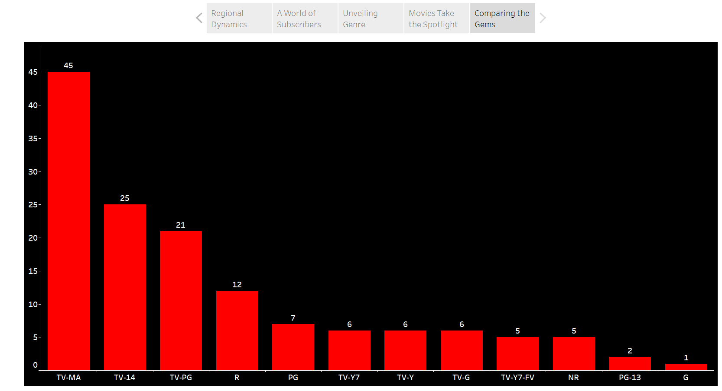

# Conclusion:-

# Storytelling in data analysis is a game-changer. When we compare data presentations with and without storytelling, the difference is clear. Without storytelling, data can be dry and difficult to interpret. But with storytelling, data becomes engaging, relatable, and memorable.

# Storytelling humanizes data, connecting with the audience on an emotional level. It influences decision-making and drives action. In a data-driven world, the ability to tell a compelling data story is invaluable. It empowers effective communication and inspires change, turning raw data into a powerful tool for transformation.

**Date:-**23-10-2023. **Signature of faculty in-charge**

# Post Lab Question:

# Explain the need of story in your words.

# Ans)

# Context and Clarity:-Storytelling provides context, making data more understandable by explaining its significance.

# Engagement and Retention:-Stories engage the audience and make data more memorable.

# Influence and Action:-Effective storytelling can guide decision-making and prompt actions based on data insights.